NHS Learning Support Fund – social media example posts for current students

2024/25

General messages
X | Have you started a pre-reg healthcare course? Take a look @NHSBSA_LSF and see if you’re eligible for additional funding support during your studies https://bit.ly/3hTqZu6 #NHSLSF | 
Facebook | Have you started a pre-reg healthcare course? Take a look @LearningSupportFund and see if you’re eligible for additional funding support during your studies https://bit.ly/3hTqZu6 #NHSLSF | 
Instagram | Are you on a pre-reg healthcare course? Did you know, you can apply for funding support from @NHSBSA_LSF? 💙  Follow them to find out more or search for NHS Learning Support Fund 🔍
X | Make sure you follow @NHSBSA_LSF for all the latest information and useful tips for the NHS Learning Support Fund.  From travel expenses to grants, the #NHSLSF is here for you 💙 | 
Facebook | Make sure you follow @LearningSupportFund for all the latest information and useful tips about the NHS Learning Support Fund.  From travel expenses to grants, the #NHSLSF is here for you throughout your university journey 💙 | 
Instagram | Want to know more about the support you can get as a healthcare student? 💙 Keep up with the latest from the NHS Learning Support Fund. Follow @NHSBSA_LSF | 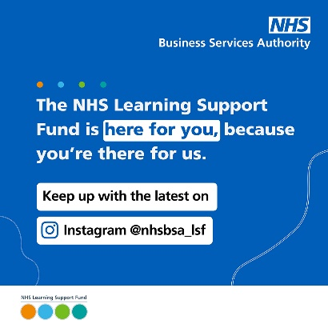
X | Are you a new healthcare student? You can apply now for funding support from @NHSBSA_LSF 👉 https://bit.ly/3hTqZu6 | 
Facebook | Are you a new healthcare student? You can apply now for funding support from @LearningSupportFund 👉 https://bit.ly/3hTqZu6 | 
Instagram | Are you a new healthcare student? 🚑 You can apply now for funding support from @NHSBSA_LSF.  Follow them to find out more or search for NHS Learning Support Fund 🔍

Parental support
X | Are you a healthcare student? Do you have parental responsibility for one or more children? You could receive £2,000 from @NHSBSA_LSF.  Find out more 👉 https://bit.ly/2V9E8We #NHSLSF | 
Facebook | Are you a healthcare student with parental responsibility for a child? 👶  Did you know you could get £2,000 Parental Support from the @LearningSupportFund?  Check out their website for more information 👉 https://bit.ly/2V9E8We | 
Instagram | Did you know? 💡  If you’re a healthcare student with parental responsibility, you could get £2,000 Parental Support from @NHSBSA_LSF 👶  Head to their Instagram to find out more.

Travel and Dual Accommodation Expenses
X | Healthcare students can claim travel and temporary accommodation expenses through @NHSBSA_LSF TDAE 🚗 🏡  For more info, take a look at their website https://bit.ly/2YnBnmp #NHSLSF | 
Facebook | Once you’ve been on a clinical placement, you can claim back the cost of some travel and accommodation. Make sure you keep hold of your invoices, receipts and travel tickets 🚗 🏡  For more information about claiming travel and accommodation, visit @LearningSupportFund https://bit.ly/2YnBnmp | 

Instagram | Calling healthcare students! 📣  Once you’ve been on a clinical placement, you can claim back the cost of some of your travel and accommodation expenses. But make sure you keep hold of your invoices, receipts and travel tickets! 🚗 🏡  For more information about claiming travel and accommodation, visit @NHSBSA_LSF or search for NHS LSF TDAE 🔍 | 

Exceptional Support Fund
X | If you’re a healthcare student and find yourself in genuine and unforeseen financial difficulty you could get help from @NHSBSA_LSF ESF.  Find out more 👉 https://bit.ly/3hKS3vP #NHSLSF | 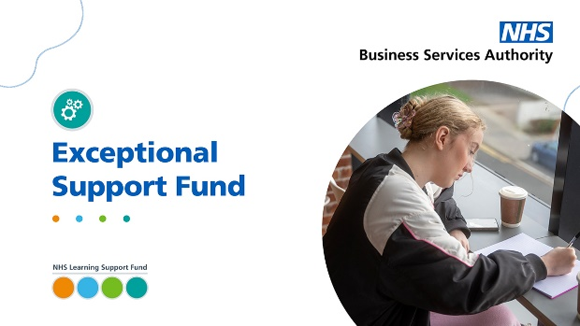
Facebook | Anyone can find themselves in unexpected financial difficulty. But the Exceptional Support Fund is here to help healthcare students who are struggling 💙  Find out more, including how to apply @LearningSupportFund 👉 https://bit.ly/3hKS3vP | 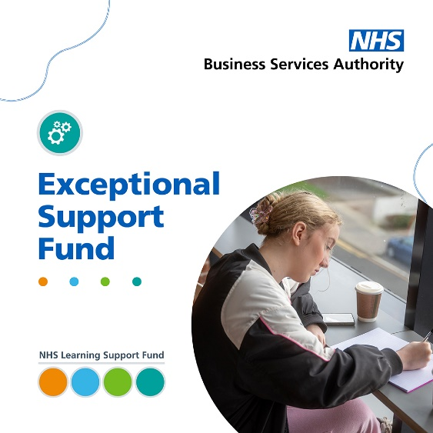
Instagram | Anyone can find themselves in unexpected financial difficulty. But the Exceptional Support Fund is here to help healthcare students who are struggling 💙  You could claim a grant of up to £3,000 per academic year, and you can apply at any point during your studies.  Find out more by searching for LSF ESF or follow @NHSBSA_LSF.

Specialist Subject Payment
Facebook | Are you a healthcare student? Did you know, you can get an extra £1,000 in funding each academic year if you’re studying:  🔹mental health nursing  🔹 learning disability nursing  🔹 radiography (diagnostic and therapeutic)  🔹 prosthetics and orthotics  🔹 orthoptics and podiatry  That’s on top of the £5,000 Training Grant for eligible students. To find out more, visit https://www.nhsbsa.nhs.uk/nhs-learning-support-fund-lsf/training-grant | 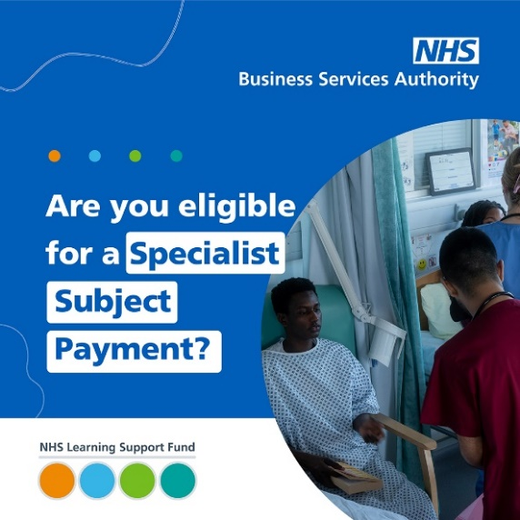
Facebook | Thinking about studying a healthcare subject at uni? 🏥 🎓  Did you know, you can get an extra £1,000 in grant funding each academic year if you study:  🔹 mental health nursing  🔹 learning disability nursing  🔹 radiography (diagnostic and therapeutic)  🔹 prosthetics and orthotics  🔹 orthoptics and podiatry  That’s on top of the £5,000 Training Grant for eligible students. To find out more, visit https://www.nhsbsa.nhs.uk/nhs-learning-support-fund-lsf/training-grant | 